**YOKOHAMA VICTORIOUS AT IRC RALLY SAN MARINO**

The current Intercontinental Rally Challenge, IRC Production class is proving very exciting this season with several contenders for the title. Jarkko Nikara and his co-driver Jarkko Kalliolepo performed an impressive win in the category at San Marino over the weekend and achieved an overall 5th place in the event.

The Finnish pair, on a Subaru Impreza R4 STI, supported by the Tommi Makinen racing team and on YOKOHAMA ADVAN A053 tyres worked intensively throughout the gravel event to ensure not only fast times but survival too. The heat, winding roads and mountainous region of the oldest republic in the world was tough for many competitors who were forced to abandon early. Among them, the current class Champion Toshi Arai assisted by Dale Moskatt, who where forced to retire following mechanical problems encountered in stage 3.

The strong performance by Nikara at San Marino now positions him in contention for the title, having had an initial setback in his inaugural event at IRC in Corsica, when he had to retire from the competition due to a gearbox failure.

Upon receiving the production cup trophy in San Marino, Nikara expressed his delight with the result and thanked his co-driver and the support team for their efforts in making the victory possible.

The current production class table is being led by Andreas Aigner, whilst Andreas Mikkelsen, is enjoying a comfortable lead at the top in the general classification.

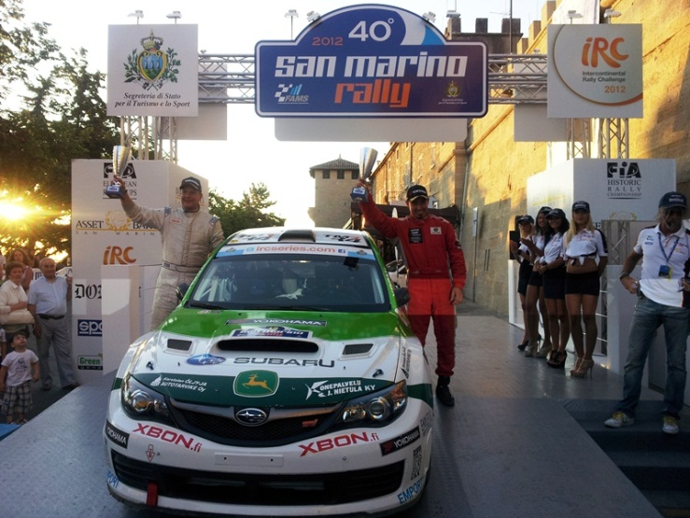

**Notes to Editors**

**YOKOHAMA is one of the leading Tyre manufacturers in the world and is Official Tyre supplier for;**  
FIA World Touring Car Championship (WTCC) – since 2006  
European Touring Car Cup (ETCC) – since 2005  
Intercontinental Rally Challenge  (IRC) – since 2007  
Scandinavian Touring Car Championship (STCC) – since 2010  
Russian Touring Car Championship (RTCC) – since 2006  
Chinese Touring Car Championship (CTCC) – since 2010  
Irish Touring Car Championship (ITCC) – new for 2012  
International Formula 3 Grand Prix Macau – since 1983   
ATS German Formula 3 – until 2005 and since 2007

FIA F2 Championship – new for 2012  
Japanese Formula 3 – since 2011

ADAC GT Masters new for 2012

GT Asia new for 2012